**CMPE 273 – Lab 1**

**Sricheta Ruj (SJSU ID - 012527606)**

**Calculator-**

**Goal :**  To Develop a calculator.

**Purpose of the system**: The purpose of the system is to develop a real-like Calculator. The Calculator includes following functionalities:

1. Addition
2. Subtraction
3. Division
4. Multiplication
5. Modulo
6. Clear button to clear the operation
7. Support of Decimal

**Technology Used**:

* React as View in MVC architecture
* Node JS as a platform to host rest services.
* ExpressJS as a web application framework.
* axios to call the REST service.

**Architecture Diagram:**

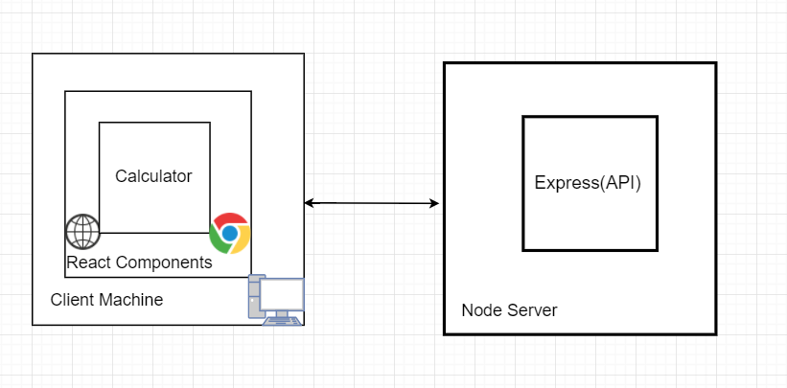

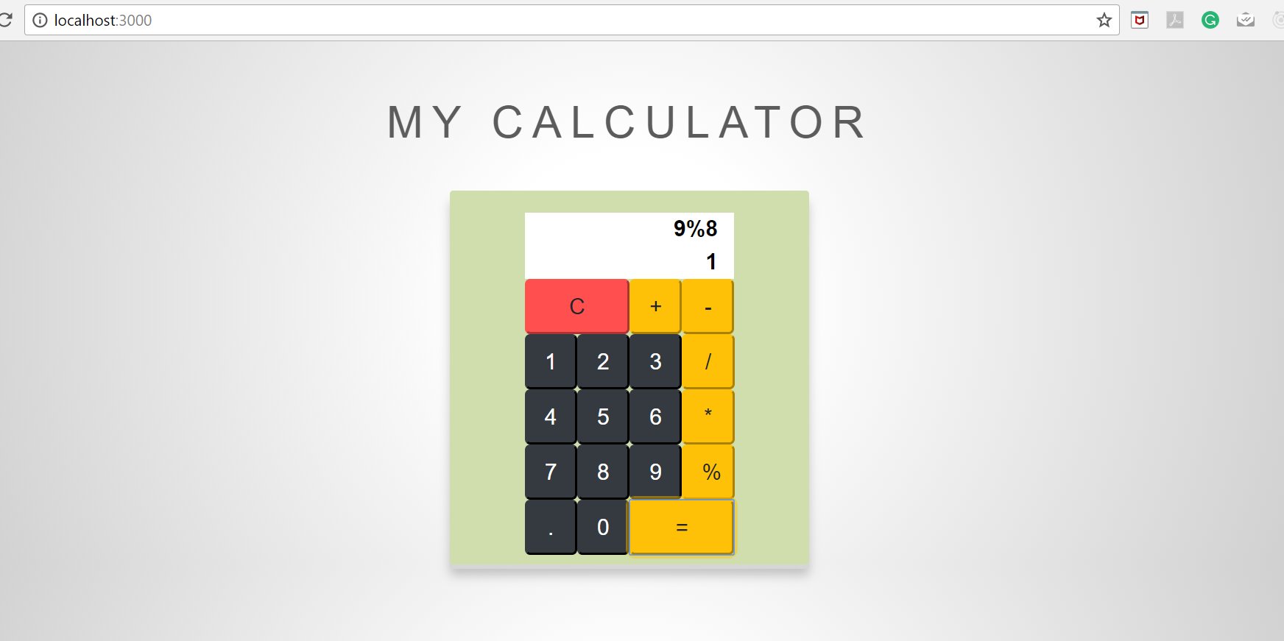

**Error and Exception Handling :**

* Return as Error when tried to divide any number by 0

